**Job Applicant Information Pack**

Lay Worker for Hospitality, Pastoral Care and Children

St. Andrew’s Psalter Lane Church &

Highfield Trinity Methodist Church,

Sheffield.

Thank you for your interest in the role of **Lay Worker for Hospitality, Pastoral Care & Children**. This pack provides more details about our church communities and the application process.

If you have any questions or would like an informal conversation about the role, please contact:

📩 Anna Calvert, Chair of the Ecumenical Church Council

annacalvert1@gmail.com

**About Us**

**St Andrew’s Psalter Lane Church (SAPLC):** SAPLC will be the main site for this role. We are an Anglican/Methodist Local Ecumenical Partnership, celebrating both traditions in our worship and practice. We are committed to being a **welcoming and inclusive** church, striving to create a **community of warmth and hospitality** for everyone.

SAPLC is located in a **quiet residential area**, about **a mile from Sheffield city centre**. Nearby there are plenty of independent shops and cafes, several schools and lots of green spaces.

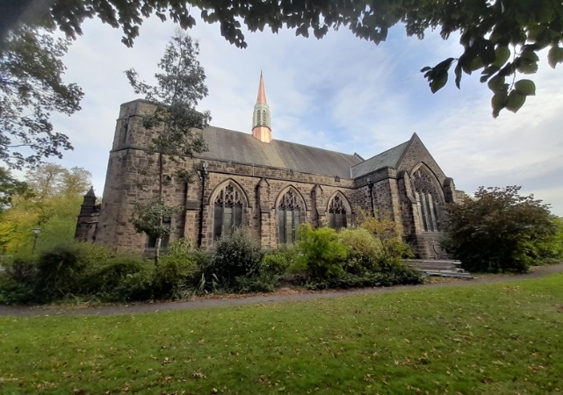

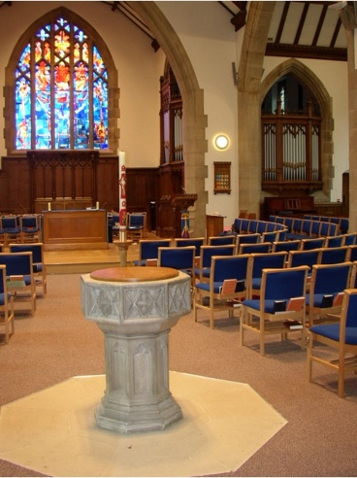

**Membership**

We have a current membership of 125, and a total community roll of over 150. We have an average congregation of 75 plus, with an additional 40 joining each week online and via podcast. Membership is mainly in the upper age ranges, but we have several younger families and a Junior Church of up to 12 members.

**Inclusive Church**

We are committed to inclusion and are part of the inclusive church network. We seek to celebrate and affirm every person.

We practice an open table, welcoming all—regardless of background or tradition—to share in communion as part of our inclusive and hospitable faith community.

**Things that matter for many of us include…**

* The desire to help create a different kind of world where gift and grace, dignity and worth, and building community drive our purpose and reason for living.
* To care for the earth. We seek to be committed to challenging injustice both locally and globally, working for the preservation and fair distribution of the earth’s resources.
* To seek a world where there is a deeper understanding and respect between the various expressions of faiths.
* To seek a world where the weak, the poor, the vulnerable and the marginalised are treated with equality, respect, and care.

We ask questions and wonder at answers, deepening our understanding of the call to discipleship through worship, learning together and nurturing faith.

**Highfield Trinity Methodist Church:**

Part of the role is to lead the work of the **Parent and Toddler group** which meets at and is supported by the congregation of Highfield Trinity Church. Highfield Trinity is a **welcoming church** with strong links with community organisations, the arts, and a **passion for outreach.**

Highfield Trinity Methodist Church is situated in a richly multicultural neighbourhood, near London Road in the Highfield area of the city, approximately a mile from Sheffield city centre.

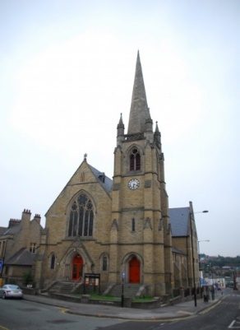

The congregation at Highfield prioritise **Creativity, Sanctuary** and **Wellbeing,** and seek to shape all ministry and mission through this lens.

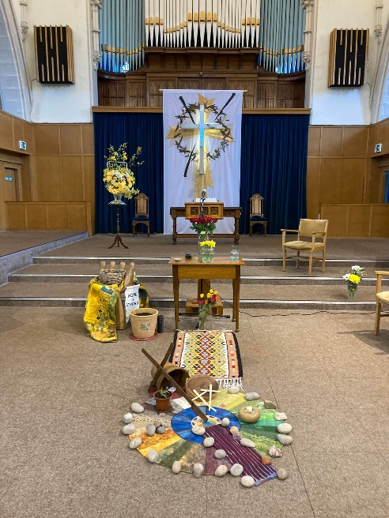

**The application process**

1. Please complete the application form, available on our website:  
   🌍 <https://www.standrewspsalterlane.org.uk>
2. Send completed forms to:  
   Mary Mitchell, Church Steward

📩 [mary.e.mitchell14@gmail.com](mailto:mary.e.mitchell14@gmail.com)

If you have any questions or wish to discuss any aspect of the role, please do not hesitate to contact:  
Anna Calvert, Chair of the Ecumenical Church Council:

📩  [annacalvert1@gmail.com](mailto:annacalvert1@gmail.com)

We are committed to making the recruitment process accessible. **If you require any accommodations at any stage of the application, please let us know.**

**Important dates**

📅 **Application Deadline:**

Noon, 22nd April 2025

📆 **Interviews:** 1st May 2025

