From Louis Nawa, former head teacher of Kafue Secondary School and resident of Kafue, Zambia writes

…the weather hasn't been the best for Zambia too in the last couple of years. Climate change has taken its toll this side of mother earth too. We have had droughts in the last two years more serious last year when most parts of Southern province there was no harvest of maize as the crops had simply withered around December/2018/January 2019. I had been travelling to Masuku, Choma during the period and what we saw was beyond the usual droughts as all crops died before the maize could even reach knee height.

The rivers also dried up and what you may have seen on TV regarding the Victoria Falls and the Kariba Dam was frightening. The Victoria Falls on the Zambian side was reduced to a trickle in a few places and you know what that means for the Electricity generation plants along the Zambezi River then; no water meant less capacity to generate electricity. As you know for us the Hydro electricity generation is the main source and with the population having grown in the last few years what was being made available could not suffice to serve every need. The resulting scenario was massive load shedding on a scale never experienced previously. Periods of 20 hours without power were not strange in some areas, it might have changed now that the flow of water has increased somewhat in the Rivers. Expansion of generating stations was not taken care of during the last two decades while industry and towns grew without exception. Hunger spread everywhere in Zambia but as you may have read the political leadership refused to accept the situation as a national disaster despite many organisations and Diplomatic Missions requesting that the authorities do so to make it possible for international assistance to be accessed. The Zambia we have is different from what you remember in your times here.

The rains are with us but with new challenges even in the towns: Flash flooding on scales not experienced before. Rivers and streams in the Luangwa National Park and surrounding areas became inundated with too much water and flooded villages sweeping bridges and many crossing points cutting off areas leaving the villagers hungry as their stored foods were destroyed in the flooding. In the townships especially Lusaka, poor drains created their own havoc as they could not carry the overwhelming volumes of water and the result was flooded roads, houses causing destruction to household goods. Main cause of this township flooding is poor drains or none at all coupled with dumping rubbish in the same drains causing blockages, so man made problems. …

That is about the weather/climate issues in Zambia. One hopes that the current rains continue so that the crops may grow and provide a good harvest later this year may be hunger could be averted. …

So pray for good rains in Zambia.

Rev. Caroline Wickens, a former mission partner in Zambia writes…

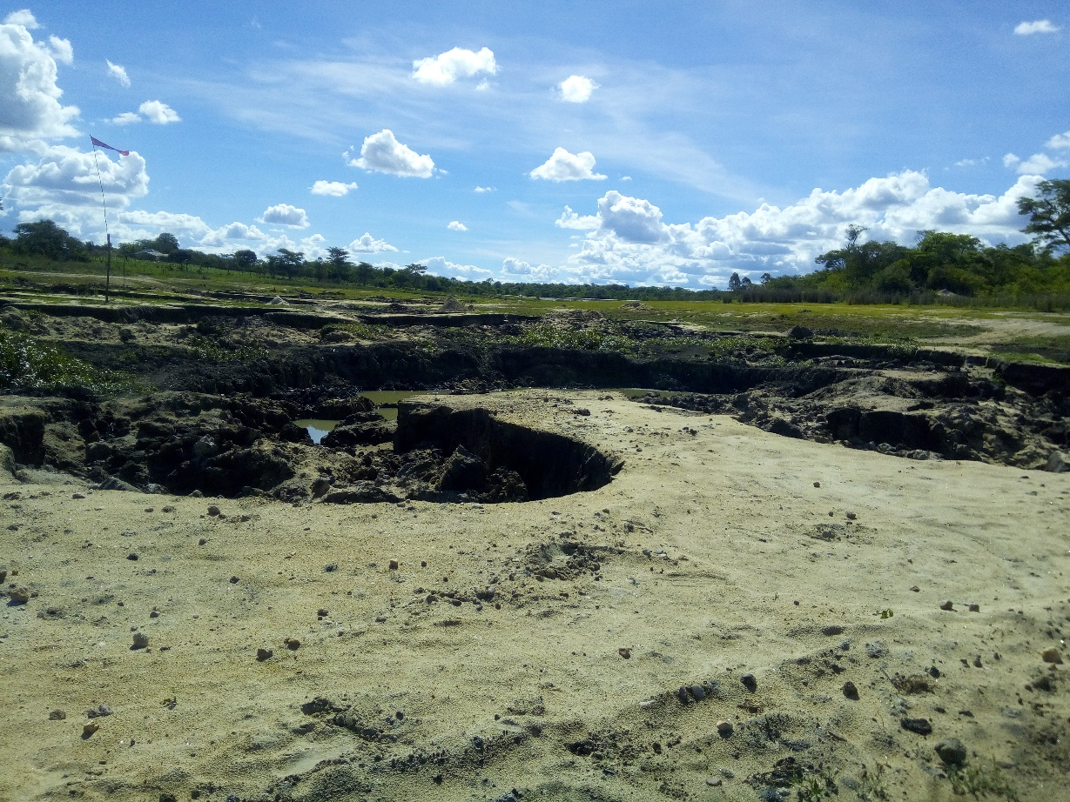

I've heard from Jenny [Jenny Featherstone is a mission partner currently in Choma, Southern Province]and several other sources about the huge problems with drought in Southern Province. The picture above is her image of Choma dam, where people have been digging for sand in the base, where there ought to be two metres of water. There has been information and interviews on the BBC and Guardian websites too, including a horrifying image of Vic Falls reduced to a trickle. They have had some rain so far this year, but it doesn't look to be anything like enough. This is impacting on the whole country because of the lack of water for hydro, but it's worst for the people in Southern, who are dying.

…

We could look for ways of fund-raising: Jenny's guidance on this is that it would be especially useful to support projects to reduce the use of charcoal, as cutting trees is making the problems worse. She suggests that Chodort, the project at Choma, would benefit from a machine for making briquettes from banana stalks and assorted plant waste.

I'm sure there are a few things I've forgotten from my conversation with Jenny, and other folk will have other ideas. If you are interested in pursuing this, please join in the discussion so we can work out together how best to take this forward. We may not be able to make much difference, but it would be good to do what we can, 

Best wishes

Rod Hill

Chari of Trustees of AFRIKAM, a registered charity supporting communities in Zambia

Former mission partner in Zambia.