Today’s activities are about Christ stilling the storm. There is a crafty activity and a jigsaw to colour in and cut out.
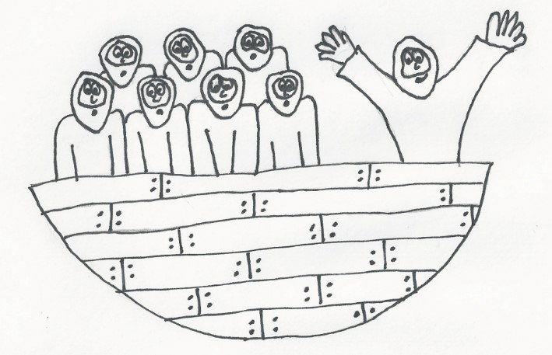

Cut out the boat with Jesus and the disciples in it and colour it in

Stick a lollipop stick (or a strip of thick cardboard) to the back of the boat

Draw or paint a stormy background

Cut wavy strips of blue paper and stick them down across the bottom of the background, but only put glue at the ends – not the middle!

Put the lollipop stick between the gaps in the waves and make the boat rock!

It should look a bit like this when it’s finished:
