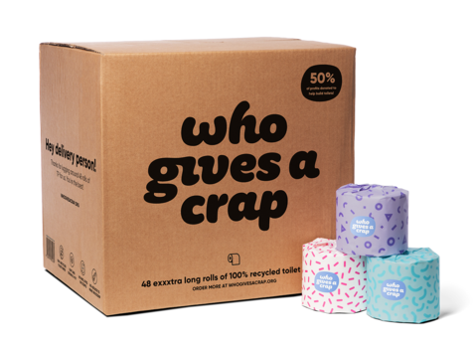
Toilet paper that builds toilets

There is a company called
WHO GIVES A CRAP
This is their website
https://uk.whogivesacrap.org/

They make recycled toilet paper – which is very good quality - and they dedicate half their profits to charity to build toilets for those who have none.

You can buy from them on line, and you can take out a subscription so that you get a delivery every 12 weeks. A box of 48 rolls is enough for 2-3 people for that time.
A box of 48 rolls (each roll is quite large and tightly rolled) costs £36. If you buy ten boxes at a time the price goes down to £29 a box.

If nine of us got together to set up a subscription we could order 10 boxes which would cost us each 32.22 every 12 weeks and we could donate the 10th box to the food bank. The rolls are ideal for them because they come individually wrapped.
I’m happy to put in the order and bear the upfront cost and have them delivered to our house. We will then tell you that they have arrived and bring them to church so that you can pick them up. When the order is about to arrive I will alert you and ask you to make the payment by BACS transfer.
If you would like to join in this idea please fill out the form on the back of this form and give it back to me. Once I have found eight other people I will let you know and put the order in.
Imogen Clout

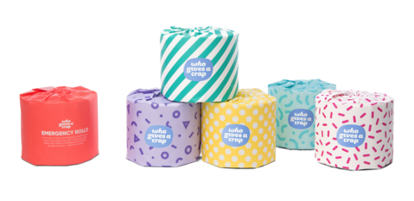

I would like to join in the bulk buy of toilet rolls and promise to pay a one-ninth share of a 10 roll subscription every 12 weeks*. I agree that we should give the tenth box to the Firth Park Food Bank.

Name:___________________________________________

Email:______________________________________________

Telephone:_________________________________________

Signature:_____________________________________. Date:___________________________

*At present prices £32.22

Tear off this part and give it to Imogen Clout
……………………………………………………………………………………………………………

